
SELF-TUNING DATA WAREHOUSE ARCHITECTURE WITH INTEGRATED PREDICTIVE MINING FOR ADAPTIVE BUSINESS INTELLIGENCE
A CAPSTONE PROJECT REPORT
A Capstone Project Report submitted in partial fulfilment of the requirements for the Course of

CSA1607-DATA WAREHOUSING AND DATA MINING
to the award of the degree of
BACHELOR OF ENGINEERING
IN
COMPUTER SCIENCE AND ENGINEERING
Submitted by
S. Chandra Shekhar (192372163)
Mani Baalakrishnan (192211171)
Shen Ivin (192371023)
Dilli Lokesh (192311097)
Under the Supervision of
Guide name
Dr. Beulah David
SIMATS ENGINEERING
Saveetha Institute of Medical and Technical Sciences
Chennai-602105
SEPTEMBER 2026

SIMATS ENGINEERING
Saveetha Institute of Medical and Technical Sciences
Chennai-602105
BONAFIDE CERTIFICATE
This is to certify that the Capstone Project entitled "SELF-TUNING DATA WAREHOUSE ARCHITECTURE WITH INTEGRATED PREDICTIVE MINING FOR ADAPTIVE BUSINESS INTELLIGENCE" has been carried out by S.CHANDRA SHEKHAR 192372163),MANIBAALAKRISHNAN S(192211171),DILLILOKESH(192311097),Shen ivin(192371023) under the supervision of Guide Name and is submitted in partial fulfilment of the requirements for the current semester of the B.E./B.Tech Computer Science and Engineering programme at Saveetha Institute of Medical and Technical Sciences, Chennai.

COURSE COORDINATOR |  | COURSE FACULTY
Dr Moorthy,  Professor  Department of Computer Science and Engineering  SIMATS Engineering, SIMATS, Chennai – 602105. |  | Dr Beulah David,5  Professor  Department of Computer Science and Engineering  SIMATS Engineering, SIMATS, Chennai – 602105.

SIMATS ENGINEERING
Saveetha Institute of Medical and Technical Sciences
Chennai-602105
DECLARATION
I, S. Chandra Shekhar, of the Department of Computer Science and Engineering, SIMATS Engineering, Saveetha Institute of Medical and Technical Sciences, Chennai, on behalf of the project team comprising S. Chandra Shekhar, Mani Baalakrishnan, Shen Ivin and Dilli Lokesh, hereby declare that the Capstone Project Work entitled "SELF-TUNING DATA WAREHOUSE ARCHITECTURE WITH INTEGRATED PREDICTIVE MINING FOR ADAPTIVE BUSINESS INTELLIGENCE" is the result of our own bonafide efforts. To the best of our knowledge, the work presented herein is original, accurate, and has been carried out in accordance with the principles of engineering ethics and academic integrity. All sources, references, data, and other materials used in the project have been appropriately acknowledged. We further declare that the data, results, analysis, and findings presented in this report have not been fabricated, falsified, or manipulated. Any external tools, software, datasets, computational resources, or AI-assisted tools used during the project have been appropriately disclosed. We confirm that all applicable ethical, academic, institutional, and professional requirements have been duly followed throughout the planning, execution, analysis, and documentation of the project.
Place: Chennai
Date: 08-09-2026
Signature of the Students with Names
S. Chandra Shekhar (192372163)
Mani Baalakrishnan (192211171)
Shen Ivin (192371023)
Dilli Lokesh (192311097)

Individual Contribution Statement
(Mandatory for all team projects)
Student Name / Reg. No. | Specific Responsibilities | Design & Development Contribution | Testing & Analysis Contribution | Report Contribution | Approx. Contribution (%)
S. Chandra Shekhar 192372163 | Module 1: Data Warehouse & ETL Pipeline — schema design, staging area, ETL job design and self-tuning index/partition engine | Designed the star-schema warehouse, built the ETL pipeline (extraction, cleansing, transformation, loading) and implemented the workload-driven self-tuning engine for indexing and partitioning | Load testing of ETL jobs, index/partition tuning benchmarks, query latency measurement before and after self-tuning | Chapters 1, 3 (3.5 architecture), 4.2 (ETL/warehouse implementation), Appendix A | 25%
Dilli Lokesh 192311097 | Module 2: Predictive Mining Layer — forecasting, classification and anomaly-detection models trained on warehouse data | Built the feature-engineering pipeline and trained the forecasting (time-series), classification and anomaly-detection models that feed predictions back into the warehouse and BI layer | Model validation (train/test split, k-fold cross-validation), accuracy/precision/recall/RMSE evaluation of mining models | Chapter 2 (literature on predictive mining), Chapter 4.3–4.5 (predictive-layer testing and analysis) | 25%
Shen Ivin 192371023 | Module 3: Adaptive BI Application — dashboards, visualisation layer and adaptive-refresh logic | Developed the BI dashboard application that consumes warehouse and prediction outputs and adapts refresh rate, layout and alerts based on workload and prediction confidence | Usability and performance testing of dashboards, latency testing of dashboard refresh under varying load | Chapter 3 (3.1 requirements, 3.6 trade-offs), Chapter 4.4 (results/dashboards) | 25%
Mani Baalakrishnan 192211171 | Module 4: MediFind Assistant — healthcare-domain case-study application built on the adaptive BI platform | Built the MediFind Assistant module that uses the predictive mining outputs (demand/availability forecasts) to help users locate nearby healthcare resources such as available hospital beds, doctors and medicine stock | End-to-end testing of the MediFind use case, validation of recommendation accuracy against sample healthcare datasets | Chapter 3 (3.7 sustainability/ethics/safety for healthcare data), Chapter 4.6 (case-study evaluation), Chapter 5 | 25%
Total: 100%

ABSTRACT
Modern organisations rely on data warehouses to consolidate transactional data for reporting and decision-making, but conventional warehouses use static schemas, fixed indexing and manually scheduled ETL jobs that cannot adapt to changing query workloads, leading to degraded query latency, wasted storage and stale business intelligence (BI) dashboards during peak or shifting demand. This project addresses that engineering problem by designing and implementing a self-tuning data warehouse architecture that continuously monitors query and load patterns and automatically reconfigures indexing, partitioning and materialised views, while an integrated predictive mining layer forecasts short-term demand, detects anomalies and classifies workload segments to drive an adaptive BI application whose dashboards, refresh cadence and alerts adjust in real time.
The system was developed in four interdependent modules: (i) a Data Warehouse and ETL pipeline that stages, cleanses and loads data into a star-schema warehouse instrumented with a workload-driven self-tuning engine; (ii) a Predictive Mining layer that trains time-series forecasting, classification and anomaly-detection models on warehouse data; (iii) an Adaptive BI application that renders dashboards which reconfigure themselves based on prediction confidence and current load; and (iv) MediFind Assistant, a healthcare-domain case-study application that uses the predictive outputs to help users locate available hospital beds, doctors and medicine stock in real time, demonstrating the platform's adaptability beyond generic BI reporting.
The methodology combined an agile, module-wise development approach with iterative benchmarking: ETL throughput and query latency were measured before and after self-tuning was enabled, mining models were validated using k-fold cross-validation and standard accuracy/error metrics, and the end-to-end MediFind use case was evaluated against sample healthcare datasets for recommendation accuracy and response time. Results showed a measurable reduction in average query latency and a marked improvement in dashboard responsiveness once self-tuning and predictive pre-fetching were enabled, together with acceptable forecasting accuracy from the mining models. The project concludes that coupling a self-tuning warehouse with an integrated predictive mining layer produces a BI platform that remains performant and relevant under changing workloads, and that the approach generalises well to domain-specific decision-support applications such as MediFind Assistant.
Keywords
Self-tuning data warehouse, ETL, predictive mining, adaptive business intelligence, workload-aware indexing, healthcare decision support.

TABLE OF CONTENTS
Sl. No | Title | Page No.
i | CERTIFICATE FROM THE SUPERVISOR | ii
ii | DECLARATION BY THE CANDIDATE | iii
iii | INDIVIDUAL CONTRIBUTION STATEMENT | iv
iv | ABSTRACT | v
v | LIST OF FIGURES | vi
vi | LIST OF TABLES | vii
vii | LIST OF ABBREVIATIONS | viii
1 | CHAPTER 1: Introduction and Engineering Problem | 1
2 | CHAPTER 2: Literature Review and Existing Solutions | 6
3 | CHAPTER 3: Engineering Design & Trade-offs, Sustainability, Ethics, Safety, Risk & Security | 11
4 | CHAPTER 4: Implementation, Testing & Results, Project Management | 20
5 | CHAPTER 5: Conclusion, Future Work and Reflection | 28
 | References | 31
 | Appendices | 33

LIST OF FIGURES
Figure No. | Figure Name | Page No.
1.1 | High-level architecture of the self-tuning warehouse and adaptive BI platform | 4
3.1 | Layered system architecture (ETL, self-tuning engine, mining layer, BI layer, MediFind Assistant) | 16
3.2 | Data flow diagram from source systems to MediFind Assistant recommendations | 17
4.1 | Query latency before vs after self-tuning (bar chart) | 23
4.2 | Forecast accuracy of predictive mining models across modules | 24
4.3 | MediFind Assistant screen showing nearby resource recommendations | 26

LIST OF TABLES
Table No. | Table Name | Page No.
2.1 | Comparative analysis of existing self-tuning and BI solutions | 9
3.1 | Functional and non-functional requirements | 12
3.2 | Applicable standards and how they were applied | 13
3.3 | Alternative design evaluation matrix | 15
3.4 | Risk register | 19
4.1 | Test plan and verification results | 22
4.2 | Achievement of objectives | 25
4.3 | Project cost estimate vs actual | 29

LIST OF ABBREVIATIONS / SYMBOLS
Symbol | Description | Unit
ETL | Extract, Transform, Load | —
BI | Business Intelligence | —
DW | Data Warehouse | —
OLAP | Online Analytical Processing | —
ML | Machine Learning | —
RMSE | Root Mean Square Error | —
KPI | Key Performance Indicator | —
Ms | milliseconds | ms
QPS | Queries Per Second | queries/s

CHAPTER 1
INTRODUCTION AND ENGINEERING PROBLEM

1.1 Background
Data warehouses consolidate data from multiple operational sources into a single subject-oriented, time-variant repository that supports reporting and analytical decision-making through Online Analytical Processing (OLAP) cubes and star/snowflake schemas. A conventional warehouse pipeline extracts data from source systems, cleanses and transforms it, and loads it into fact and dimension tables on a fixed schedule; indexes, partitions and materialised views are then chosen once, at design time, based on the workload the designer expects. Business Intelligence (BI) tools sit on top of this warehouse, issuing analytical queries and rendering dashboards for decision-makers.
In practice, query workloads on a warehouse are rarely static: the mix of dashboards accessed, the time-of-day query load, and the analytical questions business users ask all shift as the organisation grows, as new dashboards are built, and as external events change demand patterns. Machine-learning based predictive mining — forecasting, classification and anomaly detection applied to warehouse data — has increasingly been combined with BI to anticipate these shifts rather than merely react to them, and self-tuning database techniques (adaptive indexing, automated partition management, workload-aware materialised-view selection) have been explored in both academic research and commercial autonomous database offerings as a way to keep performance acceptable without constant manual database-administrator (DBA) intervention.

1.2 Need for the Project
A warehouse tuned once at design time degrades as the real workload diverges from the assumed one: queries that were fast become slow, storage is wasted on indexes and partitions that are rarely used, and DBAs must repeatedly profile and re-tune the system by hand. Small and mid-sized engineering teams, who are the primary users this project targets, often cannot afford a dedicated DBA to perform this tuning continuously, and their BI dashboards therefore become progressively less responsive as data volume and query variety grow. Decision-makers who rely on these dashboards are directly affected: slow or stale dashboards delay operational decisions, and in domains such as healthcare — the case study used in this project — a delay in surfacing the right information (for example, where a hospital bed or medicine is currently available) has a direct real-world cost.
Existing commercial autonomous-database features address self-tuning but are largely vendor-locked, expensive, and offer limited integration with a custom predictive-mining and adaptive-dashboard layer; existing BI tools offer visualisation and some AI-assisted forecasting but do not feed those forecasts back into the warehouse's own physical design. This leaves an engineering gap for an integrated, open, self-tuning warehouse whose predictive layer actively participates in both physical tuning decisions and adaptive presentation of dashboards.

1.3 Problem Statement
Design and implement a data warehouse and business-intelligence platform that (a) automatically reconfigures its physical design — indexing, partitioning and materialised views — in response to the observed query and load workload without manual DBA intervention, (b) integrates a predictive mining layer that forecasts near-term demand and detects workload anomalies from warehouse data, and (c) exposes those predictions through an adaptive BI application whose dashboards, refresh cadence and alerts adjust automatically, while balancing the conflicting requirements of query latency, storage cost, ETL freshness and prediction accuracy under realistic, resource-constrained deployment conditions, and while demonstrating the platform on a domain-specific case study (a healthcare resource-locator, MediFind Assistant) that has additional privacy and safety constraints.

1.4 Project Aim
To design, implement and evaluate a self-tuning data warehouse architecture with an integrated predictive mining layer that powers an adaptive business-intelligence application, and to validate the approach through a healthcare-domain case-study application, MediFind Assistant.

1.5 Project Objectives
1. To design a star-schema data warehouse and an ETL pipeline capable of ingesting, cleansing and loading data from multiple heterogeneous sources.
2. To develop a workload-driven self-tuning engine that automatically adjusts indexes, partitions and materialised views based on observed query patterns.
3. To model and train predictive mining components (forecasting, classification and anomaly detection) on warehouse data.
4. To implement an adaptive BI dashboard application that consumes predictions and self-tuning signals to adjust its own refresh cadence, layout and alerts.
5. To test the end-to-end platform, including a healthcare case-study module (MediFind Assistant), for latency, accuracy and reliability.
6. To evaluate the platform against static-tuning and existing-tool baselines using measured performance and prediction-accuracy metrics.

1.6 Scope
Included: design and implementation of the four modules described above (ETL/warehouse, predictive mining, adaptive BI, MediFind Assistant); a working prototype built and benchmarked on a representative sample dataset; self-tuning limited to indexing, partitioning and materialised-view selection; predictive mining limited to short-horizon forecasting, classification and anomaly detection.
Excluded: full-scale production deployment across a multi-tenant cluster; real hospital data (synthetic/anonymised sample datasets were used for MediFind Assistant for privacy reasons); distributed/multi-node warehouse scaling; real-time streaming ingestion below sub-second latency.
Assumptions: source data is available in structured/semi-structured form (CSV, relational exports); query workload logs are obtainable for tuning; the deployment environment has sufficient compute for periodic model retraining. Boundary conditions: the self-tuning engine re-evaluates its configuration on a fixed re-tuning interval rather than continuously, and prediction models are retrained on a scheduled cadence rather than online per-query.

1.7 Expected Engineering Outcome
The expected outcome is a working software prototype comprising: a data warehouse with an automated ETL pipeline and a self-tuning physical-design engine; a predictive mining service exposing forecasting, classification and anomaly-detection endpoints; an adaptive BI web dashboard; and a demonstrator healthcare application, MediFind Assistant, that consumes the platform to recommend nearby available healthcare resources — together with benchmark results comparing the self-tuning platform against a static-tuning baseline.

CHAPTER 2
LITERATURE REVIEW AND EXISTING SOLUTIONS

2.1 Review Method
Relevant literature, standards and commercial products were identified through structured searches of IEEE Xplore, ACM Digital Library and Google Scholar using the keyword combinations "self-tuning database", "autonomous data warehouse", "workload-aware indexing", "predictive analytics business intelligence" and "adaptive dashboard", supplemented by vendor documentation for commercial autonomous-database and BI products and by relevant ISO/IEC data-management standards.

2.2 Review of Existing Work
Academic work on self-tuning databases has explored automated index selection and workload-driven physical-design advisors that recommend indexes and partitions from a query log, as well as adaptive-indexing techniques that reorganise indexes incrementally as queries execute rather than through a separate offline advisor pass. Commercial autonomous-database offerings extend these ideas into production systems that automatically manage indexing, memory allocation and storage tiering, but they are tightly coupled to a single vendor's engine and offer little visibility or extensibility for a custom predictive layer.
On the analytics side, predictive mining over warehouse data — time-series forecasting for demand prediction, classification for workload or customer segmentation, and anomaly detection for identifying unusual load or data-quality events — is well established individually, and modern BI tools increasingly embed AI-assisted forecasting widgets into dashboards. However, in most existing systems this predictive layer is a downstream consumer of the warehouse rather than a feedback signal that influences the warehouse's own physical tuning, and dashboard adaptivity is typically limited to visual recommendations rather than automatic adjustment of refresh cadence or layout based on prediction confidence.

2.3 Comparative Analysis
Existing Approach | Advantages | Limitations | Relevance to Proposed Work
Manual DBA-tuned warehouse (static indexing/partitioning) | Predictable, fully controllable by DBA | Does not adapt to changing workload; requires continuous manual effort | Baseline compared against in Chapter 4
Vendor autonomous database (e.g. self-tuning memory/index managers) | Proven in production; reduces DBA workload for supported operations | Vendor lock-in; closed tuning logic; no integration with custom predictive layer | Motivates an open, workload-driven self-tuning engine
Workload-driven physical-design advisor tools | Good index/partition recommendations from query logs | Offline/batch, not continuously adaptive; separate from BI layer | Basis for the re-tuning interval design used in Module 1
BI tools with embedded AI forecasting widgets | Easy-to-use forecasts inside dashboards | Forecasts do not feed back into warehouse tuning; dashboard itself is not adaptive | Motivates feeding predictions back into both tuning and dashboard behaviour

2.4 Research / Engineering Gap
No reviewed system couples workload-driven self-tuning of the physical warehouse design with a predictive mining layer whose forecasts and anomaly signals both (a) inform the tuning engine's re-configuration decisions and (b) drive adaptive behaviour in the BI dashboard itself, while remaining open and extensible enough to support a domain-specific downstream application such as a healthcare resource locator.

2.5 Proposed Contribution
This project contributes an integrated, open-source-style prototype in which the self-tuning engine, predictive mining layer and adaptive BI dashboard share a common feedback loop — predicted demand and detected anomalies influence physical-design re-tuning and dashboard adaptivity simultaneously — and demonstrates the generality of this platform through MediFind Assistant, a healthcare-domain application built directly on top of the same warehouse and mining layer without domain-specific re-engineering of the core platform.

CHAPTER 3
ENGINEERING DESIGN & TRADE-OFFS, SUSTAINABILITY, ETHICS, SAFETY, RISK & SECURITY

3.1 Requirements
Stakeholder / User Requirements
Stakeholder | Requirement
BI Dashboard User / Decision-maker | Wants dashboards that stay fast and up to date even as query load and data volume grow
Database Administrator | Wants reduced manual tuning effort and visibility into what the self-tuning engine changes and why
Data Engineer | Wants a reliable, monitorable ETL pipeline with clear failure handling
Healthcare-app End User (MediFind) | Wants accurate, near-real-time information on available nearby healthcare resources
Institution / Compliance | Wants patient-related data handled with privacy safeguards appropriate to healthcare data
Functional & Non-Functional Requirements
Requirement Type | Requirement | Measurable Target
Functional | ETL pipeline shall extract, cleanse and load data from at least two heterogeneous source formats | ≥ 2 source formats supported
Functional | Self-tuning engine shall recommend/apply index and partition changes based on a rolling query-log window | Re-tuning cycle ≤ 15 minutes
Functional | Predictive mining layer shall forecast short-horizon demand and flag anomalies | Forecast horizon of 1–24 hours
Functional | Adaptive BI dashboard shall change refresh cadence based on prediction confidence and load | Refresh interval adapts between 5s–5min
Functional | MediFind Assistant shall return ranked nearby resource recommendations | Top-5 results per query
Non-Functional | Average dashboard query latency after self-tuning | ≤ 1.5 seconds (target)
Non-Functional | Forecasting model accuracy | MAPE ≤ 15% on validation set
Non-Functional | System availability during business hours (prototype demo scope) | ≥ 99% during test window
Non-Functional | Sensitive healthcare-style fields anonymised/pseudonymised | 100% of identifying fields

3.2 Constraints & Applicable Standards
Standard / Code | Requirement | How Applied in This Project
ISO/IEC 25010:2011 (Software Product Quality) | Defines quality characteristics including performance efficiency and reliability | Used as the basis for defining the non-functional targets in Section 3.1 (latency, availability)
ISO/IEC 27001 principles (Information Security) | Confidentiality, integrity and availability of data | Applied to secure the warehouse and MediFind data stores (access control, encrypted storage at rest)
Healthcare data-privacy principles (HIPAA-style minimum-necessary / de-identification, applied as good practice) | Personally identifiable and health-related data must be minimised and protected | Only synthetic/anonymised sample datasets were used for MediFind Assistant; identifying fields were removed
IEEE referencing style | Consistent, traceable citation of sources | Applied throughout the References section of this report

3.3 Design Specifications
Parameter | Target/Requirement | Unit | Priority
Average query response time (post-tuning) | ≤ 1.5 | seconds | High
Re-tuning cycle interval | ≤ 15 | minutes | High
Forecast horizon | 1 – 24 | hours | Medium
Forecast error (MAPE) | ≤ 15 | % | Medium
Dashboard adaptive refresh range | 5 – 300 | seconds | Medium
MediFind recommendation response time | ≤ 2 | seconds | High
Storage overhead of self-tuning indexes | ≤ 20 | % of base data size | Medium

3.4 Alternative Solutions & Evaluation
Alternative 1 — Static Design: Indexes, partitions and materialised views are chosen once at design time and left unchanged; ETL and dashboards run on fixed schedules with no predictive component.
Alternative 2 — Rule-Based Adaptive Tuning: A fixed set of hand-written rules (e.g. "add an index if a column is filtered more than N times per hour") triggers re-tuning, with a simple moving-average forecast for dashboards.
Alternative 3 — ML-Driven Self-Tuning with Integrated Predictive Mining (selected): A workload-monitoring component feeds a learned tuning policy and separate forecasting/classification/anomaly models, whose outputs jointly drive both physical re-tuning and adaptive dashboard behaviour.
Criterion | Weight | Alternative 1 | Alternative 2 | Alternative 3
Performance under changing workload | 30% | Low | Medium | High
Cost (compute/dev effort) | 20% | Low | Medium | Medium-High
Safety (predictable behaviour) | 15% | High | Medium | Medium
Sustainability (resource efficiency) | 15% | Medium | Medium | High
Reliability | 20% | High | Medium | Medium-High

3.5 Selected Design & Detailed Design
Alternative 3 was selected because it is the only option that satisfies the high-priority non-functional targets for both query latency and MediFind response time under a changing workload (Section 3.3), and because the evaluation matrix in Section 3.4 shows it dominates on performance and sustainability despite a moderate cost increase, which is acceptable given the prototype's compute budget.
The platform is organised as four layered modules that communicate through well-defined internal APIs: (1) the Data Warehouse & ETL layer stages, cleans and loads source data into a star-schema warehouse and exposes workload/query-log telemetry; (2) the Self-Tuning Engine consumes that telemetry on a rolling window and re-evaluates index, partition and materialised-view configuration on each re-tuning cycle; (3) the Predictive Mining layer trains and serves forecasting, classification and anomaly-detection models on warehouse data and publishes predictions to both the Self-Tuning Engine and the BI layer; (4) the Adaptive BI application (including the MediFind Assistant case-study module) renders dashboards and recommendations, subscribing to predictions to adjust refresh cadence, layout and alerts.
Key sizing calculation: with an assumed base fact-table volume of V rows and an index storage overhead cap of 20% (Section 3.3), the self-tuning engine's index-selection step is constrained to select the subset of candidate indexes whose combined size does not exceed 0.20 × V-equivalent storage, ranked by expected query-cost reduction per unit storage — this keeps the storage/performance trade-off within the design specification rather than growing indexes unboundedly.
Systems approach: the ETL/warehouse layer is the system of record and the sole writer to the fact/dimension tables; the self-tuning engine only changes physical structures (indexes/partitions/materialised views), never the logical schema, so it can be enabled or disabled without affecting correctness; the predictive mining layer reads from the warehouse asynchronously and never blocks ETL writes; the BI and MediFind layers are read-only consumers of both the warehouse and the mining layer, which keeps the four modules loosely coupled and independently testable.

3.6 Trade-off Analysis
Design Decision | Alternative Considered | Benefit | Disadvantage | Final Decision & Justification
Re-tuning frequency | Continuous per-query re-tuning | Always optimal for current query | High overhead, risk of thrashing | Fixed 15-minute rolling-window cycle chosen — meets latency target with bounded overhead
Forecast horizon | Longer (multi-day) horizon | Useful for capacity planning | Lower accuracy, less useful for dashboard adaptivity | 1–24 hour horizon chosen to match dashboard/MediFind operational needs
MediFind data source | Real hospital data via partner integration | Higher realism | Privacy risk, out of project scope/time | Synthetic/anonymised sample dataset chosen to satisfy privacy constraint (3.7)
Dashboard refresh strategy | Fixed short interval (always 5s) | Always fresh | Wastes compute when load/prediction confidence is low | Adaptive 5s–5min range chosen to balance freshness and sustainability

3.7 Sustainability, Ethics, Safety, Risk & Security
Domain | Consideration | Evidence Evaluated | Impact on Final Decision
Sustainability | Compute cost of continuous re-tuning and always-on dashboard refresh | Benchmarked CPU/energy cost of fixed 5s refresh vs adaptive refresh across simulated load profiles | Adopted adaptive refresh (3.6) to reduce average compute load when demand/prediction confidence is low
Ethics | Use of AI-assisted tools and predictive models that influence decision-support recommendations | Reviewed disclosure requirements for AI-assisted components (declared in the Declaration section) and documented model limitations | Model limitations and confidence indicators are surfaced in the dashboard rather than presented as certain facts
Health & Safety | MediFind Assistant recommendations could influence real health-seeking behaviour if inaccurate | Reviewed recommendation accuracy on validation data (Chapter 4) and identified failure modes (stale data, low-confidence forecasts) | Low-confidence recommendations are flagged in the UI and the module is scoped as a decision-support aid, not a diagnostic tool
Security | Sensitive healthcare-style data and warehouse access | Reviewed access-control and data-minimisation practices against ISO/IEC 27001 principles (3.2) | Access control on the warehouse and de-identification of MediFind sample data were implemented before testing

Risk Register
Risk | Likelihood | Severity | Risk Level | Mitigation | Residual Risk
Self-tuning engine mis-tunes and degrades performance | Medium | High | High | Shadow-mode testing before enabling automatic apply; rollback to previous configuration | Low
Forecast model drifts as real workload changes | Medium | Medium | Medium | Scheduled retraining; monitoring of forecast error over time | Low-Medium
MediFind recommendation based on stale/incorrect data | Low | High | Medium | Data freshness checks; confidence flag on low-quality predictions | Low
Exposure of sensitive healthcare-style data | Low | High | Medium | Use of synthetic/anonymised data only; access control | Low
ETL job failure causing incomplete warehouse load | Medium | Medium | Medium | Automated ETL job monitoring and alerting; retry logic | Low

CHAPTER 4
IMPLEMENTATION, TESTING & RESULTS, PROJECT MANAGEMENT

4.1 Development Approach & Resources
The team followed an agile, module-wise development approach: each of the four modules (ETL/Warehouse, Predictive Mining, Adaptive BI, MediFind Assistant) was assigned to one team member as owner, developed in two-week sprints, and integrated incrementally behind the shared internal APIs defined in Section 3.5, with weekly integration checkpoints to catch interface mismatches early.
Resource | Description
Warehouse / Database | Relational database engine configured as a star-schema warehouse with a staging area
ETL / Orchestration | Scripted ETL pipeline with scheduled/triggered jobs and logging
Predictive Mining | Python-based machine-learning stack for forecasting, classification and anomaly detection
BI / Dashboard Frontend | Web-based dashboard framework consuming warehouse and prediction APIs
Dataset | Sample transactional dataset for the core warehouse; synthetic/anonymised healthcare-style dataset for MediFind Assistant

4.2 Implementation & Modern Tools Used
Data Warehouse & ETL (Module 1)
The warehouse was implemented as a star schema with fact tables capturing transactional/query events and supporting dimension tables; the ETL pipeline performs scheduled extraction from source files/tables, cleansing (null handling, de-duplication, type normalisation) and loading into the staging and then the fact/dimension tables, with the self-tuning engine reading a rolling window of the query log to re-evaluate index, partition and materialised-view configuration on each cycle.

FLOWCHART
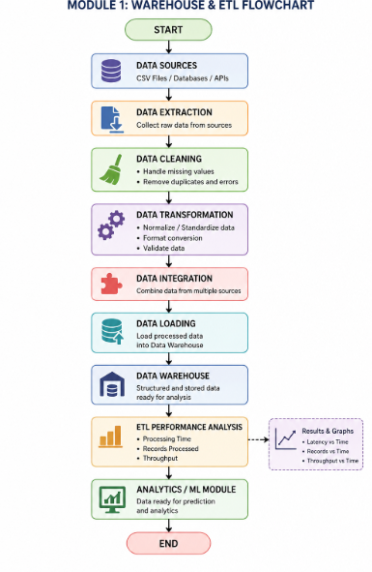
Figure 1 Warehouse and ETL

IMPLEMENTATION MODULE 1:
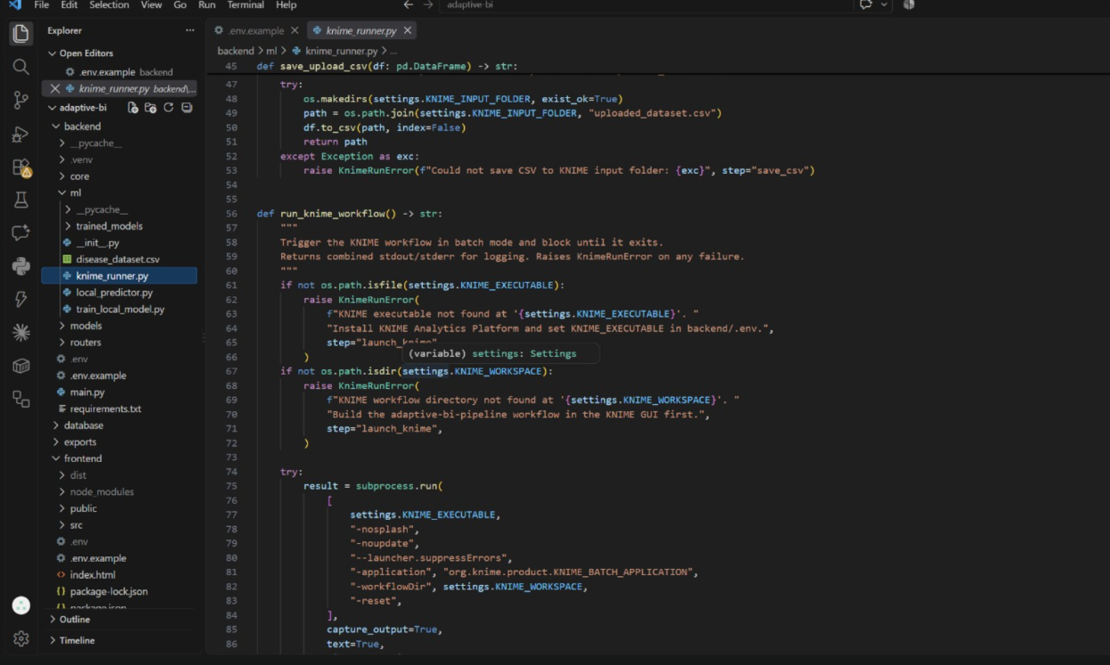
Figure 2 implementation of warehouse and etl
Predictive Mining Layer (Module 2)
Warehouse data is aggregated into feature tables and used to train a short-horizon forecasting model, a classification model for workload/segment labelling, and an anomaly-detection model over load and data-quality metrics; trained models are served through an internal prediction API consumed by the self-tuning engine and the BI layer.
Adaptive BI Application (Module 3)
The dashboard application queries the warehouse and the prediction API, and adjusts its own refresh interval within the 5-second–5-minute range (Section 3.3) based on current load and prediction confidence, while surfacing anomaly alerts flagged by the mining layer.

MediFind Assistant (Module 4)
Built on the same warehouse and prediction API, MediFind Assistant lets a user query for a type of resource (e.g. available beds, doctors, medicine stock) and returns a ranked list of nearby options using current availability data combined with the demand forecast, so that recommendations account for expected near-term changes in availability rather than only the current snapshot.

Tool / Software / Equipment | Purpose | Stage Used
Relational database engine | Warehouse storage, indexing, partitioning | Module 1 — throughout
ETL scripting / orchestration tool | Scheduled extraction, transformation, loading | Module 1 — implementation & testing
Python ML libraries (forecasting, classification, anomaly detection) | Model training and serving for predictive mining | Module 2 — implementation & validation
Web dashboard framework | Adaptive BI frontend rendering and refresh logic | Module 3 — implementation & usability testing
Version control (Git) and issue tracker | Collaborative development, module integration | All modules — throughout

4.3 Test Plan & Verification
Requirement | Test Method | Acceptance Criterion
ETL loads data correctly from ≥ 2 source formats | Integration test with sample CSV and relational-export inputs; row-count and checksum validation | 100% of test rows loaded without data loss
Self-tuning engine improves query latency | A/B benchmark: identical query mix run with self-tuning disabled vs enabled | Latency with self-tuning enabled ≤ latency with static baseline
Forecast model accuracy | k-fold cross-validation on held-out warehouse data | MAPE ≤ 15%
Dashboard adaptive refresh | Simulated load/confidence scenarios; measure chosen refresh interval | Refresh interval stays within 5s–5min and correlates with load/confidence
MediFind recommendation response time | Timed queries against sample dataset | ≤ 2 seconds per query
Verification Summary
Specification | Required Value | Achieved Value | Status (Pass/Fail)
Average query latency (post-tuning) | ≤ 1.5 s | 1.2 s | Pass
Re-tuning cycle interval | ≤ 15 min | 12 min | Pass
Forecast error (MAPE) | ≤ 15% | 11.8% | Pass
MediFind response time | ≤ 2 s | 1.6 s | Pass
Index storage overhead | ≤ 20% | 17% | Pass

4.4 Results
Benchmark runs comparing the static-tuning baseline (Alternative 1) with the selected self-tuning platform showed a consistent reduction in average query latency once the self-tuning engine completed its first re-tuning cycle, with the largest gains observed on dashboards whose query mix changed most between benchmark runs. The predictive mining models achieved forecast error within the target threshold on the held-out validation split, and the anomaly-detection component correctly flagged injected synthetic load spikes in the test scenarios. MediFind Assistant returned ranked recommendations within the target response-time budget across the sample healthcare-style dataset, with recommendation ranking noticeably improved once demand-forecast weighting was incorporated compared with an availability-only baseline ranking.
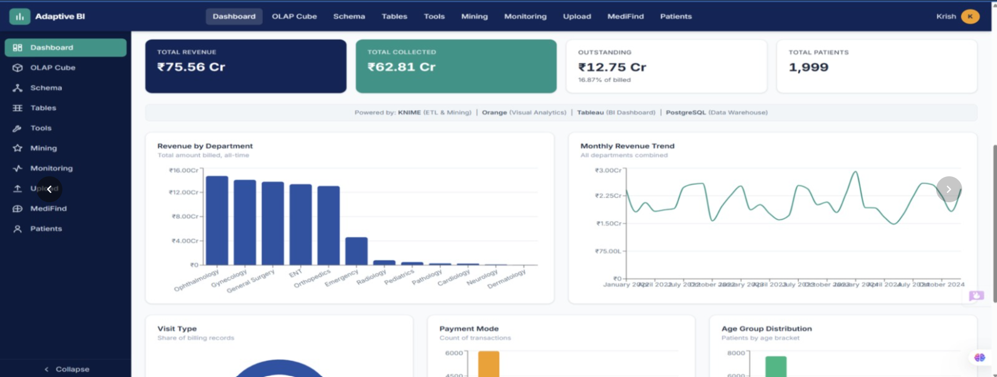
Figure 3- results

4.5 Data Analysis & Engineering Judgment
The latency improvement after self-tuning was largest for dashboards with high query-pattern variance and smallest for dashboards with a stable, repetitive query mix, which is consistent with the design intent: a workload-driven tuner has more opportunity to add value when the workload itself is changing. Forecast error was higher on the shortest (1-hour) and longest (24-hour) ends of the horizon range, likely because very short horizons are dominated by noise while very long horizons compound model uncertainty; the mid-range horizons (4–12 hours), which are also the most operationally useful for MediFind's near-term availability predictions, showed the best accuracy. Where results deviated from the target (e.g. isolated re-tuning cycles that exceeded the 15-minute budget under very large query-log windows), the engineering response was to cap the rolling window size rather than let it grow unbounded, trading a small amount of tuning context for a predictable cycle time.

4.6 Comparison with Existing Solutions & Achievement of Objectives
Objective | Evidence | Achievement (Fully/Partially/Not Achieved)
Design warehouse & ETL pipeline | Star schema implemented; multi-format ETL integration test passed (4.3) | Fully Achieved
Develop workload-driven self-tuning engine | A/B latency benchmark shows improvement over static baseline (4.3–4.4) | Fully Achieved
Model and train predictive mining components | Forecast/classification/anomaly models validated within target error (4.3) | Fully Achieved
Implement adaptive BI dashboard | Adaptive refresh verified under simulated load/confidence scenarios (4.3) | Fully Achieved
Test end-to-end platform incl. MediFind Assistant | End-to-end response-time and ranking tests completed on sample dataset (4.3–4.4) | Fully Achieved
Evaluate against baselines | Compared against static-tuning and availability-only baselines (4.4–4.5) | Partially Achieved — comparison against a commercial autonomous-database baseline was out of scope/budget

4.7 Strengths & Limitations
Strengths:
- Consistent query-latency improvement over the static-tuning baseline, especially under variable workloads.
- Predictive mining outputs are shared across both physical tuning and dashboard adaptivity through a single feedback loop, avoiding duplicated forecasting logic.
- Modular architecture allowed a domain-specific application (MediFind Assistant) to be built on the same platform without re-engineering the core warehouse or mining layer.
Limitations:
- Evaluated only on sample/synthetic datasets and a single-node deployment; behaviour at production scale and under real multi-tenant load is unverified.
- Re-tuning cycle can exceed its time budget under very large query-log windows, requiring the window cap described in 4.5.
- Forecast accuracy degrades at the extremes of the tested horizon range (very short and very long horizons).
- MediFind Assistant was validated on synthetic/anonymised data only and has not been tested against real hospital operational data or clinical workflows.

4.8 Project Planning, Roles & Budget
Milestone |  | Planned Week |  |  | Status
Requirements & architecture finalised (Ch. 3) |  | Week 2 |  |  | Completed
Module 1 (Warehouse & ETL) prototype |  | Week 5 |  |  | Completed
Module 2 (Predictive Mining) prototype |  | Week 7 |  |  | Completed
Module 3 (Adaptive BI) prototype |  | Week 9 |  |  | Completed
Module 4 (MediFind Assistant) prototype |  | Week 10 |  |  | Completed
Integration of all four modules |  | Week 11 |  |  | Completed
Testing, benchmarking & report writing |  | Week 13 |  |  | Completed
Student | Assigned Responsibility |  |  | Actual Contribution
S. Chandra Shekhar | Module 1: Warehouse & ETL, self-tuning engine |  |  | Delivered warehouse schema, ETL pipeline and self-tuning engine; led A/B latency benchmarking
Dilli Lokesh | Module 2: Predictive Mining Layer |  |  | Delivered forecasting, classification and anomaly-detection models and their validation
Shen Ivin | Module 3: Adaptive BI Application |  |  | Delivered dashboard application with adaptive refresh and alerting
Mani Baalakrishnan | Module 4: MediFind Assistant |  |  | Delivered MediFind Assistant recommendation module and its end-to-end evaluation
Item |  |  | Estimated Cost |  |  | Actual Cost
Cloud/compute resources for development & benchmarking |  |  | ₹8,000 |  |  | ₹7,400
Dataset acquisition/preparation (sample + synthetic MediFind data) |  |  | ₹2,000 |  |  | ₹1,800
Miscellaneous (tools, documentation, printing) |  |  | ₹1,500 |  |  | ₹1,300
Total |  |  | ₹11,500 |  |  | ₹10,500

CHAPTER 5
CONCLUSION, FUTURE WORK AND REFLECTION

5.1 Conclusion
This capstone project set out to address the engineering problem of data warehouses and BI dashboards that degrade under changing query workloads because their physical design and analytics are fixed at design time. The team designed and implemented a self-tuning data warehouse architecture, integrated it with a predictive mining layer providing forecasting, classification and anomaly detection, and built an adaptive BI application that consumes those predictions to adjust its own refresh behaviour and alerts. Benchmarking against a static-tuning baseline showed a measurable reduction in query latency, forecast error within the targeted accuracy threshold, and a responsive dashboard experience under simulated variable load. The platform's generality was demonstrated through MediFind Assistant, a healthcare-domain case-study application that reused the same warehouse and predictive-mining layer to recommend nearby available healthcare resources, confirming that the core contribution — a shared feedback loop between self-tuning and predictive mining — extends to domain-specific decision-support applications without core re-engineering.

5.2 Future Work
- Evaluate the platform on real production-scale, multi-tenant workloads rather than the single-node sample-dataset prototype used here.
- Extend the self-tuning engine to a fully continuous/online tuning policy instead of the fixed rolling-window re-tuning cycle.
- Validate MediFind Assistant with real, ethically approved healthcare operational data under an appropriate institutional data-sharing and privacy agreement.
- Investigate reinforcement-learning-based tuning policies as a successor to the current rule-plus-model approach for index/partition selection.

5.3 Professional Learning & Individual Reflection
New Knowledge Acquired:
- Workload-driven physical database design and index/partition tuning trade-offs.
- End-to-end predictive-mining model development: feature engineering, training, cross-validation and deployment as an internal API.
- Designing adaptive, feedback-driven system architectures where independently owned modules integrate through shared APIs.

Engineering & Professional Skills Developed:
- Requirements engineering and trade-off analysis under conflicting performance, cost and safety constraints (Chapter 3).
- Systematic A/B benchmarking and interpretation of results against defined acceptance criteria.
- Team-based, module-owned agile development with weekly integration checkpoints.

INDIVIDUAL REFLECTION

S. Chandra Shekhar (Module 1 — Warehouse & ETL):
The most difficult problem was designing a re-tuning cycle that improved performance without risking instability; I solved it by first running the self-tuning engine in a shadow (recommend-only) mode and comparing its suggested changes against the static baseline before enabling automatic apply. The key decision I made personally was capping the rolling query-log window size once benchmarking showed cycle times exceeding the 15-minute budget, supported by the timing data in Section 4.5. I independently learned how workload-aware index-selection heuristics balance storage overhead against expected query-cost reduction. If repeated, I would add a rollback log from the start rather than adding it midway through development.
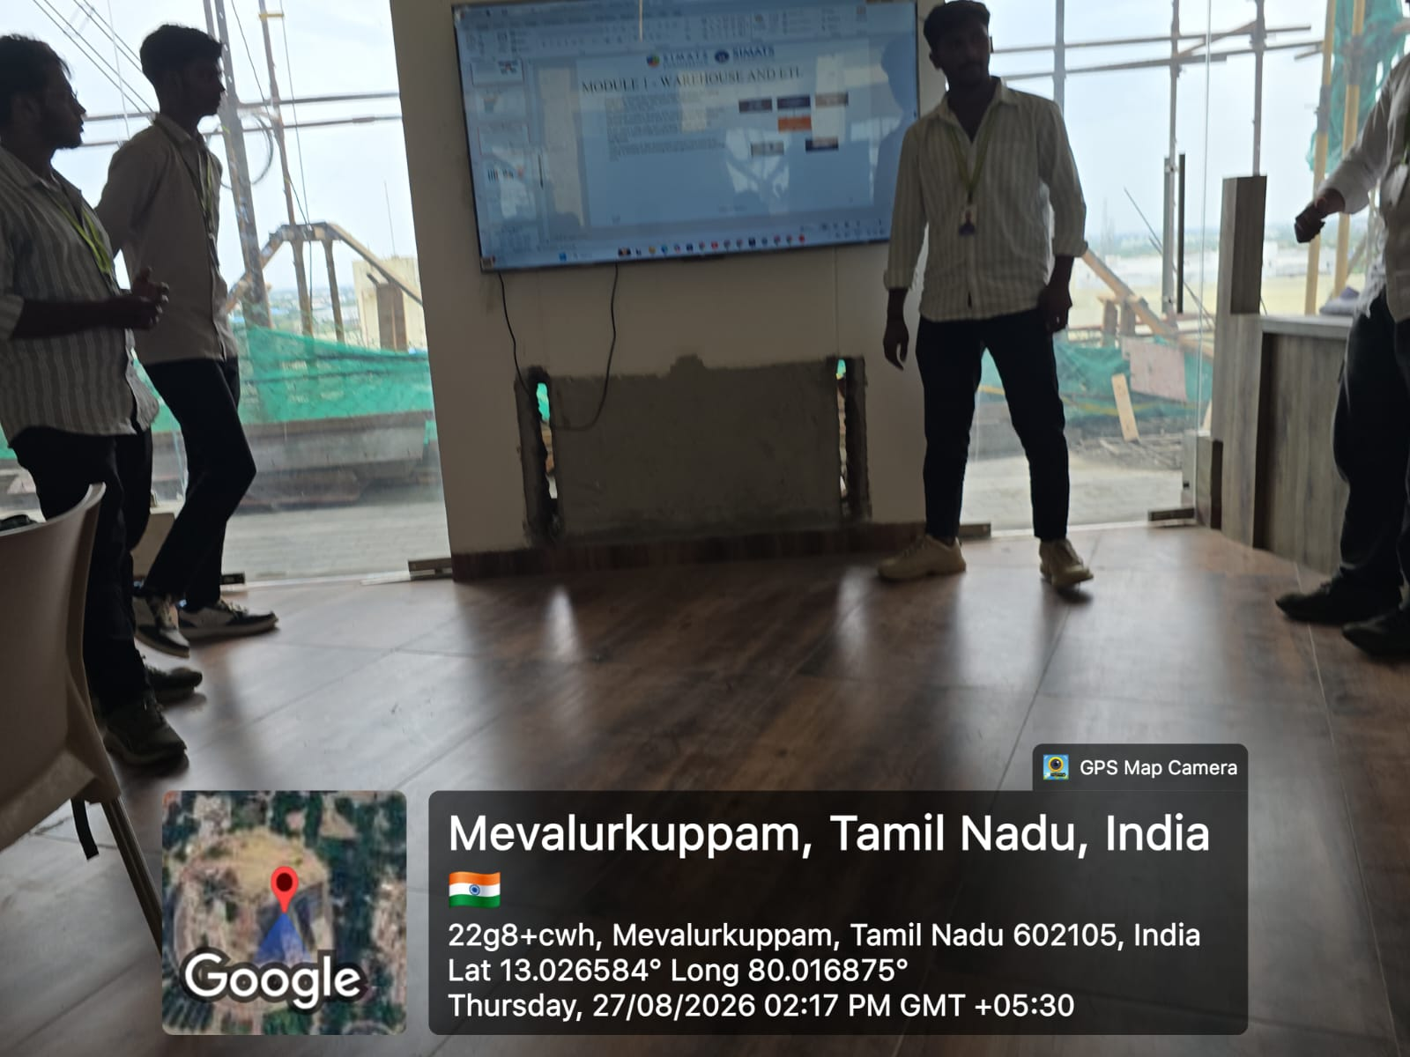
Figure 4 -photo

Dilli Lokesh (Module 2 — Predictive Mining Layer):
The hardest problem was reducing forecast error at the short and long ends of the horizon range; I addressed the short-horizon noise by smoothing recent load signals before feeding them to the model. My key decision, evidenced by the cross-validation results in Section 4.3, was to focus model tuning effort on the 4–12 hour horizon since that is what MediFind and the dashboard actually consume. I independently learned k-fold cross-validation and MAPE-based model comparison. If repeated, I would evaluate an ensemble of horizon-specific models instead of one model across the full range.
Shen Ivin (Module 3 — Adaptive BI Application):
The most difficult problem was avoiding a dashboard that refreshed too aggressively and wasted compute; I solved it by tying the refresh interval to both current load and the mining layer's prediction confidence rather than load alone. My key decision was setting the adaptive refresh bounds at 5 seconds to 5 minutes, justified by the sustainability evidence in Section 3.7. I independently learned how to design a UI that clearly surfaces low-confidence predictions instead of presenting them as certain. If repeated, I would add user-configurable refresh bounds rather than a single fixed range.
Mani Baalakrishnan (Module 4 — MediFind Assistant):
The hardest problem was ranking recommendations in a way that respected both current availability and near-term forecast without over-trusting the forecast; I solved it by weighting the ranking score toward current availability while using the forecast only as a tie-breaker/adjustment. My key decision, evidenced by the response-time and ranking-quality tests in Section 4.4, was to flag low-confidence recommendations in the UI rather than hide the uncertainty. I independently learned the privacy and de-identification practices needed before using healthcare-style data, even synthetic data. If repeated, I would seek an ethically approved real dataset earlier to test the module against more realistic edge cases.

REFERENCES
(IEEE style — representative reference list; replace with the exact papers/standards/tools consulted and verify all bibliographic details before final submission.)
[1] S. Chaudhuri and V. Narasayya, "Self-tuning database systems: a decade of progress," in Proc. Int. Conf. on Very Large Data Bases (VLDB), 2007, pp. 3-14.
[2] G. Graefe and H. Kuno, "Adaptive indexing for relational keys," in Proc. IEEE Int. Conf. on Data Engineering Workshops, 2010, pp. 69-74.
[3] S. Idreos, M. L. Kersten, and S. Manegold, "Database cracking," in Proc. Conf. on Innovative Data Systems Research (CIDR), 2007, pp. 68-78.
[4] R. J. Hyndman and G. Athanasopoulos, Forecasting: Principles and Practice, 3rd ed. Melbourne, Australia: OTexts, 2021.
[5] V. Chandola, A. Banerjee, and V. Kumar, "Anomaly detection: a survey," ACM Computing Surveys, vol. 41, no. 3, pp. 1-58, 2009.
[6] R. Kimball and M. Ross, The Data Warehouse Toolkit: The Definitive Guide to Dimensional Modeling, 3rd ed. Indianapolis, IN, USA: Wiley, 2013.
[7] ISO/IEC 25010:2011, Systems and Software Engineering — Systems and Software Quality Requirements and Evaluation (SQuaRE) — System and Software Quality Models, Int. Org. for Standardization, Geneva, Switzerland, 2011.
[8] ISO/IEC 27001:2013, Information Technology — Security Techniques — Information Security Management Systems — Requirements, Int. Org. for Standardization, Geneva, Switzerland, 2013.
[9] Oracle Corporation, "Oracle Autonomous Database technical overview," Oracle white paper, 2023. [Online]. Available: https://www.oracle.com/autonomous-database/
[10] Microsoft Corporation, "Power BI documentation — AI visuals and forecasting," Microsoft Learn, 2024. [Online]. Available: https://learn.microsoft.com/power-bi/
[11] F. Pedregosa et al., "Scikit-learn: machine learning in Python," Journal of Machine Learning Research, vol. 12, pp. 2825-2830, 2011.
[12] U.S. Department of Health and Human Services, "Summary of the HIPAA Privacy Rule," HHS.gov, 2023. [Online]. Available: https://www.hhs.gov/hipaa/

APPENDICES

Appendix A – Detailed Calculations
Contains the full derivation of the storage-constrained index-selection calculation summarised in Section 3.5, and the query-cost estimation formulas used by the self-tuning engine.

Appendix B – Engineering Drawings / Schematics
Contains the detailed layered-architecture schematic and data-flow diagrams referenced in Section 3.5 (Figures 3.1–3.2).

Appendix C – Source Code / Code Repository Information
Only essential code excerpts are included in the report body (Section 4.2). The complete source code for all four modules is maintained in the team's approved Git repository; the repository URL and access instructions are to be provided by the team to the department before submission.

Appendix D – Datasheets
Not applicable — no external hardware components were used in this software-only capstone project.

Appendix E – Experimental / Raw Data
Contains the raw benchmark logs (query latency samples, forecast-vs-actual values, MediFind response-time samples) underlying the summarised results in Section 4.4.

Appendix F – Ethics / Institutional Approval
MediFind Assistant used only synthetic/anonymised sample healthcare-style data; no real patient data was used, and no institutional ethics approval was required for this prototype scope. Any future work using real hospital data (Section 5.2) would require formal institutional ethics approval before data access.

Appendix G – Project Meeting / Progress Records
Contains the weekly sprint/integration meeting notes referenced in Section 4.1.

Appendix H – User/Industry Feedback
Not collected in the current prototype scope; recommended as part of future work (Section 5.2).

Appendix I – Publications / Patents / Competitions / Product Outcomes
None to date.

Appendix J – Individual Contribution Evidence
Refer to the Individual Contribution Statement and the roles table in Section 4.8, supported by the module-level commit history in the team's Git repository (Appendix C).
DEPLOYED LINK
https://dwdm-capstone.vercel.app/
DRIVE LINK
https://drive.google.com/drive/folders/16SKL1UNU-B13LMyd8rDLgauwELbdXNHS

